rm2

rm

Return Iterator

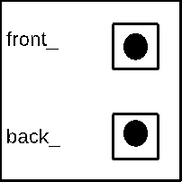



23



15



10



8

